Visual Studio 2022: How to debug a console app which runs with root privileges

## Setup Visual Studio for remote debugging

Install VsLinuxDebug from Visual Studio Marketplace.

* Visual Studio – Options… – Linux Debugger – General: Adjust .NET Path to the fully-qualified path to the dotnet executable. Check if the path to the vsdbg executable is correct.  
  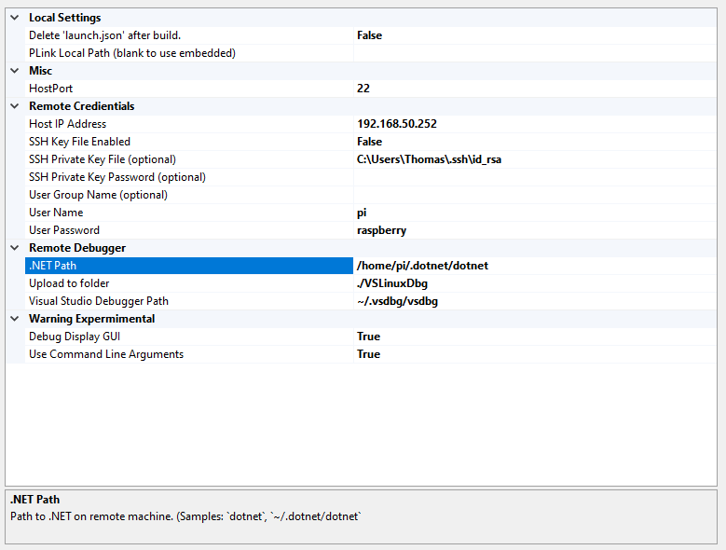
* Install vsdbg if not already done by VsLinuxDebug.  
  curl -sSL https://aka.ms/getvsdbgsh | /bin/sh /dev/stdin -v latest -l ~/vsdbg
* Connect to the remote system using putty.exe before trying to run the remote debugger.

## Run vsdbg with elevated privileges

* Rename the original vsdbg binary to something convenient:  
  mv ~/.vsdbg/vsdbg ~/.vsdbg/vsdbg-bin
* Create new text file with the name “vsdbg”:  
  sudo nano ~/.vsdbg/vsdbg
* Paste following content into the new vsdbg file, exit and save using Ctrl+X.   
  #!/bin/bash  
  sudo ~/.vsdbg/vsdbg-bin $@
* Add execute permissions to the new vsdbg file:  
  sudo chmod +x ~/.vsdbg/vsdbg

## Known Problems:

* If the raspberry pi sdcard is reinstalled with a new operating system and the same IP address is used, make sure you connect to the raspberry pi using putty.exe. It eventually shows a warning that the fingerprint of the ssh keys has changed. Agree and update to the newer fingerprint.  
  reg delete HKCU\Software\SimonTatham\PuTTY\SshHostKeys /f
* Remove old fingerprints from %userprofile%\.ssh\known_hosts file:  
  del %userprofile%\.ssh\known_hosts

Links:

<https://github.com/SuessLabs/VsLinuxDebug>

<https://marketplace.visualstudio.com/items?itemName=SuessLabs.VSLinuxDebugger>

<https://learn.microsoft.com/en-us/dotnet/iot/debugging?tabs=self-contained&pivots=vscode>